**HOW TO.**

**Set up Soundtrack your Brand with AXIS Audio Manager Edge**

**Contents**

Introduction 3

Step 1 – Sign up for Soundtrack Business subscription: 3

Step 2 – Download the Soundtrack your Brand ACAP from Axis website 4

Step 3 – Prepare the hardware 4

Step 4 – Install Soundtrack your Brand ACAP on Audio device 5

Step 5 – Add Soundtrack your Brand ACAP as a music source in Audio Manager Edge 7

Step 6 – Connect to Soundtrack your Brand 11

Considerations and limitations 12

Introduction

This “how to” document will show you how to set up the selected device with Soundtrack your Bran ACAP (AXIS Camera Application Platform) and how to manage music and volume settings in Soundtrack your Brand webpage.

The Soundtrack your Brand services establish a connection with an application running on the AXIS Audio Device to play the preferred music. The application is referred to as ACAP in this document.





**Step 1 – Sign up for Soundtrack your Brand subscription:**

**Prerequisites**

AXIS Network Audio Devices v10.10.73.2 or latest

AXIS Player for Soundtrack Business *1*.4 or latest

SD card installed in Axis Audio devices

Internet access from leading audio device

Please note that Axis doesn’t take any responsibility for how this configuration may affect your system. If the modification fails or if you get other unexpected results, you may have to restore the settings to default.

* [*https://business.soundtrackyourbrand.com/signup*](https://business.soundtrackyourbrand.com/signup)
* 14-day trial is available for testing when you set up your account.

**Step 2 – Download the** AXIS Player for Soundtrack**ACAP from the Axis website**

* <https://www.axis.com/products/audio/soundtrack-your-brand>

Step 3 – Prepare the hardware

1. Connect your Axis audio devices to the internet through Power over Ethernet (PoE).
2. Log in to the Audio leading device webpage.
3. Upgrade to the latest firmware.
4. Choose one of the devices to be the leader and insert an SD card in the SD card slot.

**NOTE**

The SD card might need formatting. You can easily see the status and format the SD card in **Systems🡪 Storage**

**NOTE**

We recommend AXIS Surveillance Card 64 GB. See

*axis.com/products/storage/axis-surveillance-card-64-gb*

Step 4 – Install AXIS Player for SoundtrackACAP on Audio device

1. In the leader device's webpage, go to Apps
2. 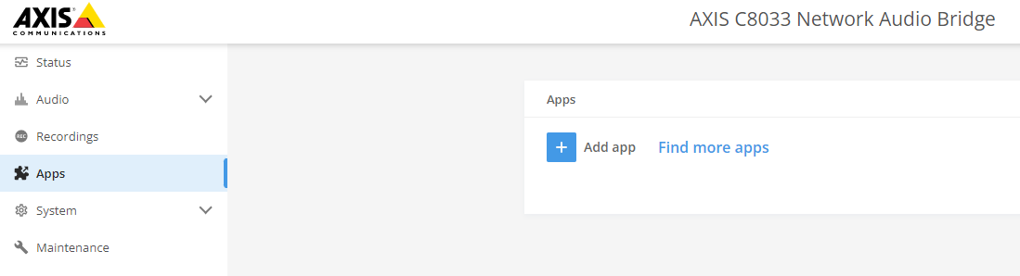Click on + Add app and select your AXIS Player Soundtrack ACAP
3. Click on install
4. Start and open the application

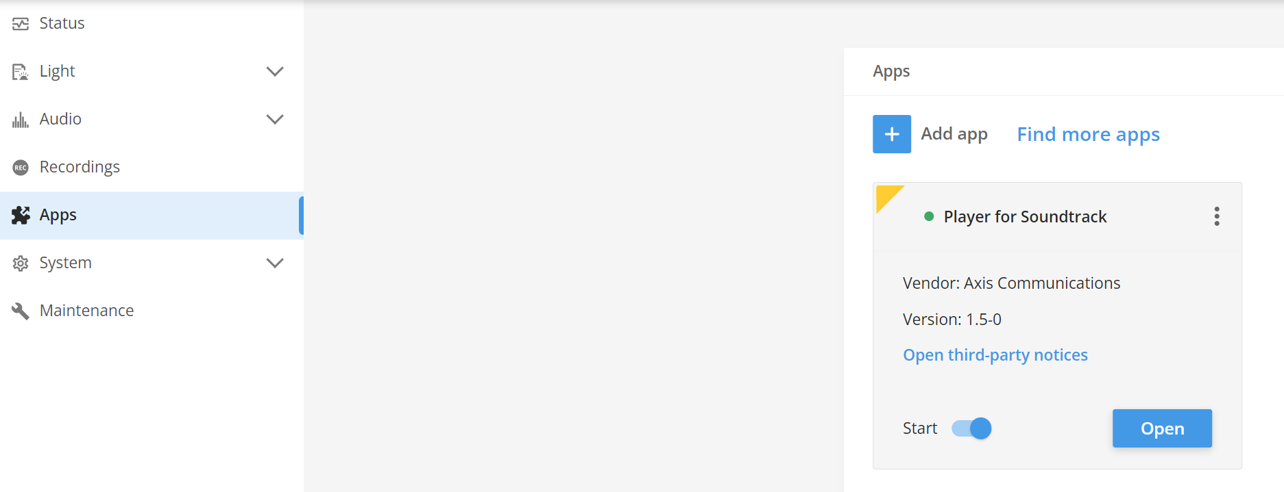

1. Once the application is opened a window will show up with application data. Notice and copy the Device ID from **About** section, it will be used later in the system.

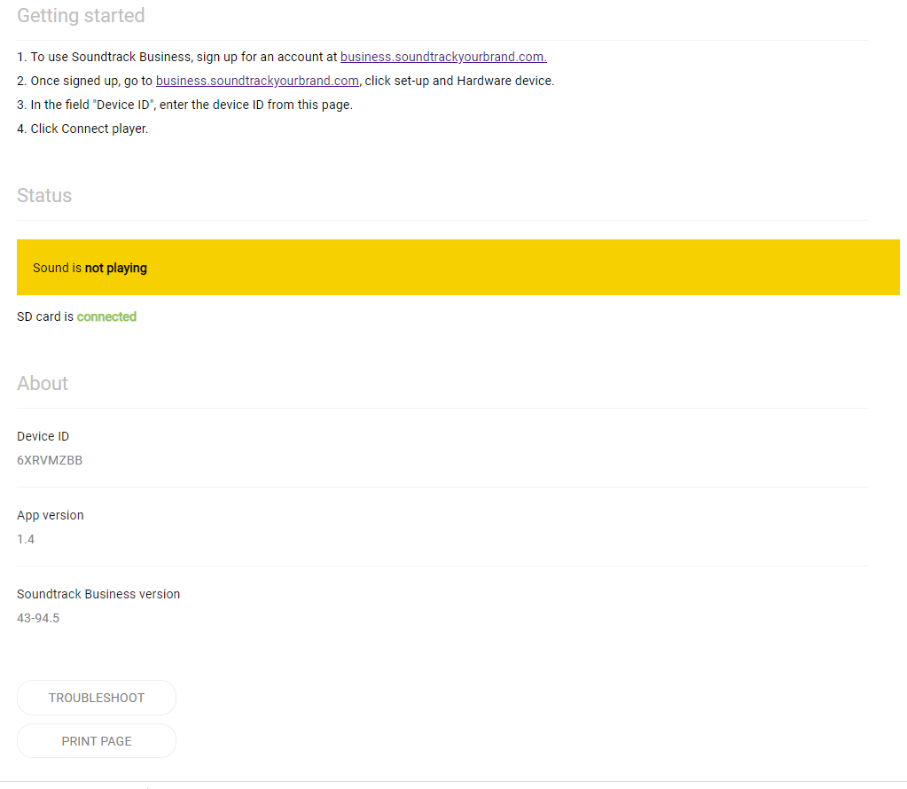

**NOTE**

The Device ID is unique for each leader device and connects the hardware with Soundtrack your brand

Application installation is now complete.



We recommend AXIS Surveillance Card 64 GB. See *axis.com/products/storage/axis-surveillance-card-64-gb*

Step 5 – Add AXIS Player for SoundtrackACAP as a music source in Audio Manager Edge

1. Go back to the device’s main web interface 🡪 **Overview 🡪 Audio 🡪 Launch Audio Manager Edge**. For more information about Audio Manager Edge visit, <https://www.axis.com/products/axis-audio-manager-edge>

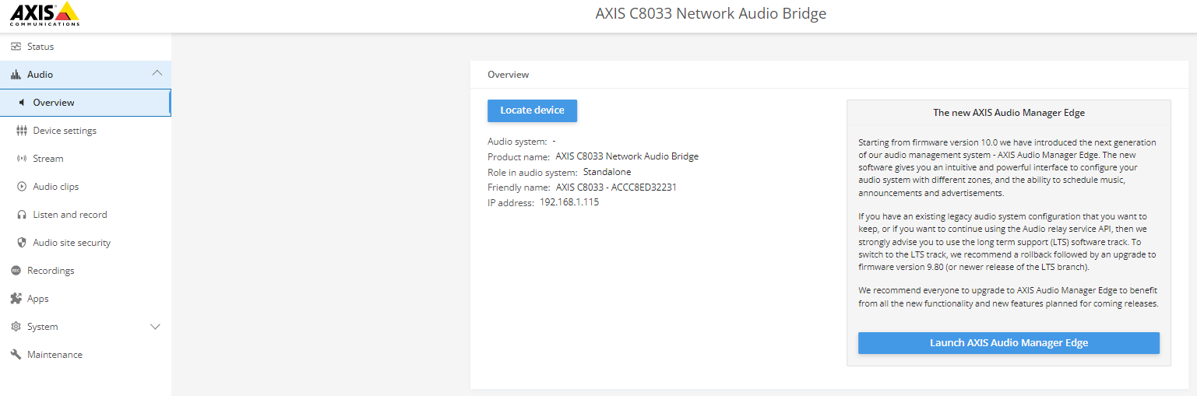

1. Agree to the EULA and enter a name for your AXIS Audio Manager Edge site. Click Create.

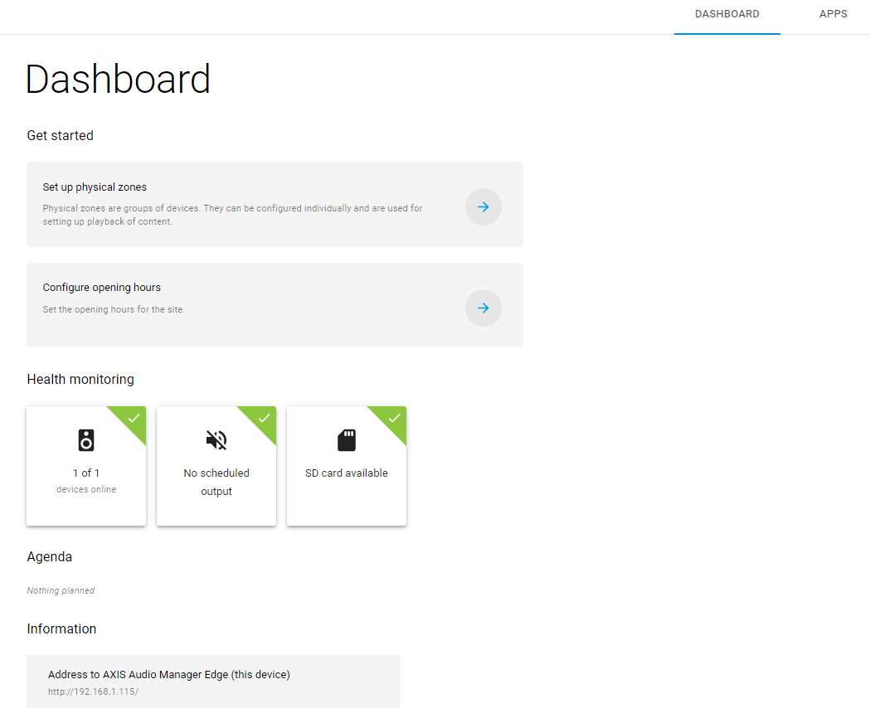

1. Set up the physical zones for the site as shown here: <https://help.axis.com/axis-audio-manager-edge#set-up-physical-zones>
2. Configure Opening hours as shown here:

<https://help.axis.com/axis-audio-manager-edge#set-the-opening-hours>

1. Add the Soundtrack your Brand application via **Scheduling 🡪 Music.**

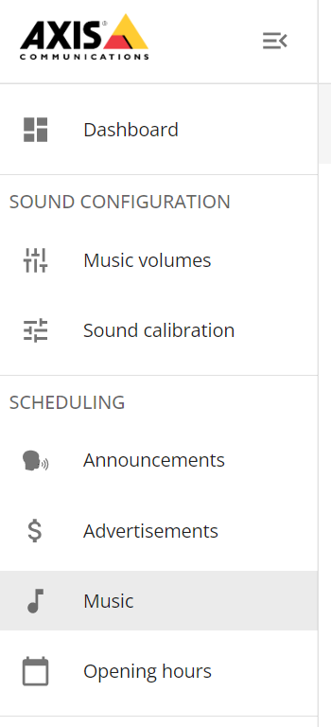

1. Under Plan click on the  icon and add the Physical zones that you want your background music played in.

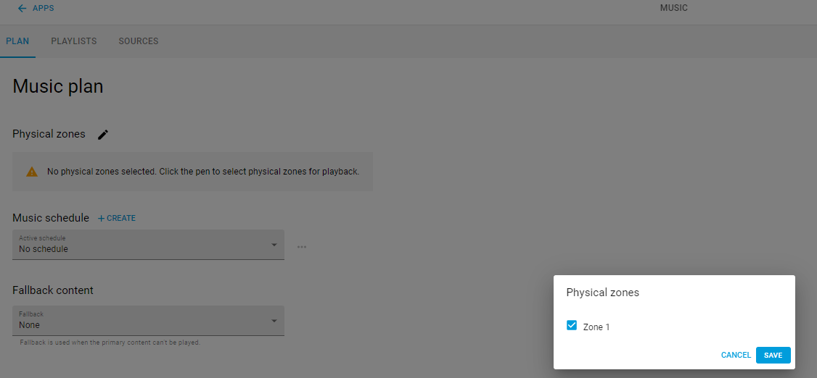

1. Click on Sources, then Create and select ACAP as the source. Give the source a name and Select SoundtrackPlayer from the ACAP dropdown and save.

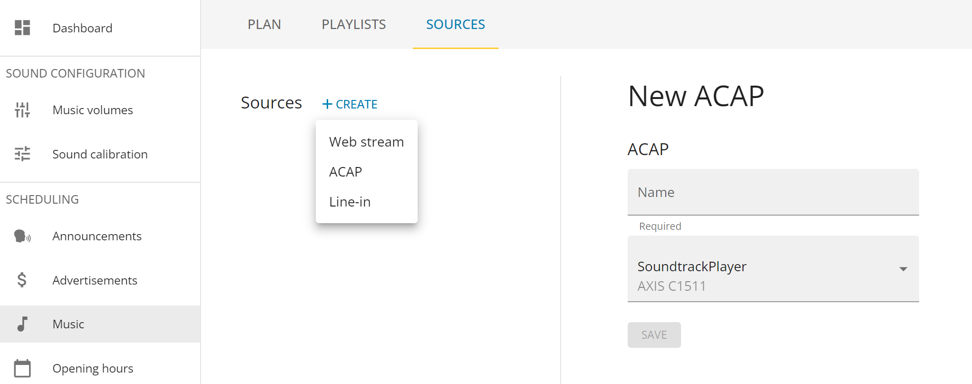

1. Go back to **Plan** and select **Opening Hours Schedules** under **Music Schedule**. Then select the source just created to be played during the scheduled time.

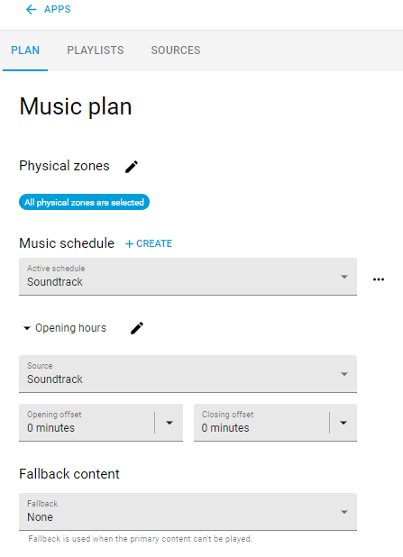

Step 6 – Connect to Soundtrack your Brand account

* 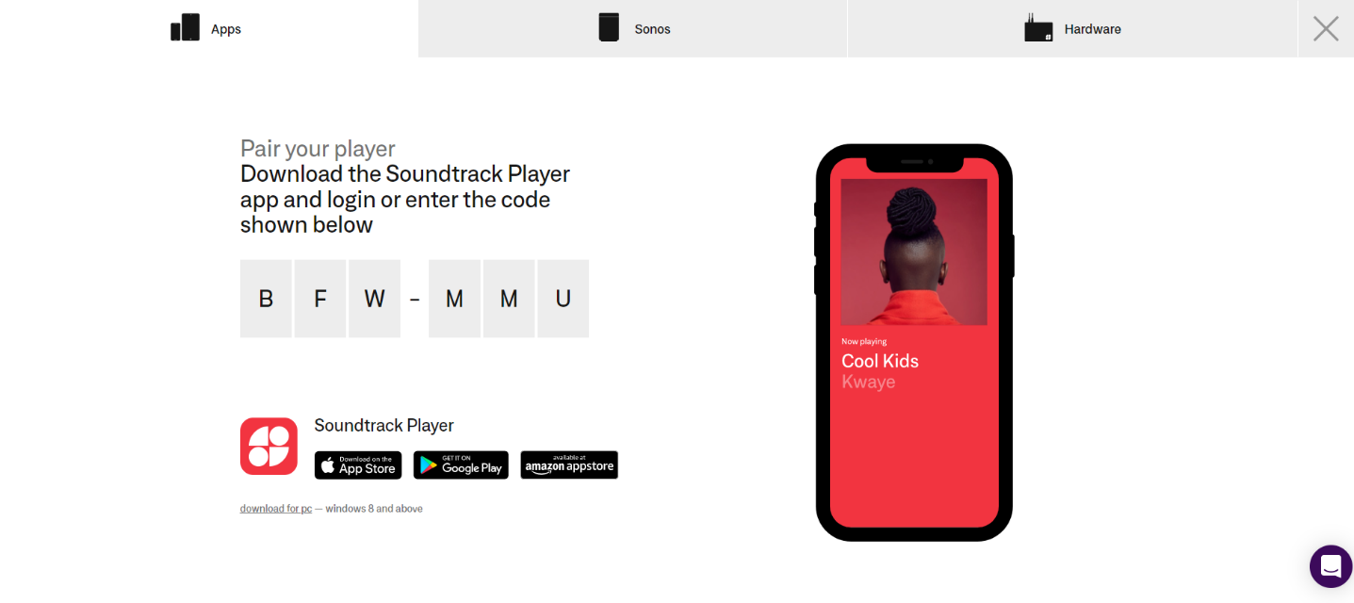Log in to Soundtrack your Brand account and setup a connection between the site and the application on the Audio Device by clicking on **Start playing music 🡪** **Hardware**.
* 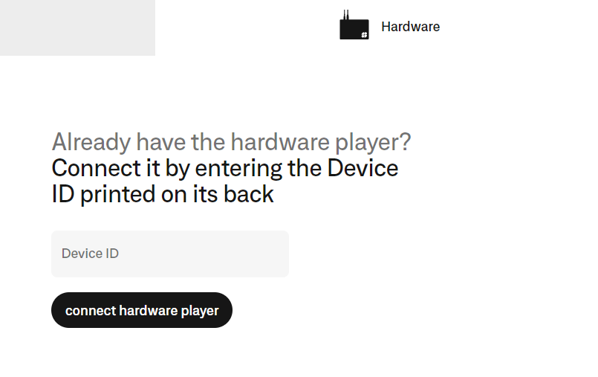Enter and connect Axis Audio device with the Device ID collected from the Soundtrack your Brand application. **Apps 🡪 Open 🡪 About 🡪 Device ID**

* Once connected, select your preferred playlist and play. The Soundtrack your Brand ACAP page should now change status to **sound is playing.** If the current time is within the scheduled opening hours, music shall be heard.

**Considerations and limitations**

Firewall configuration according to this document:

[*https://help.soundtrackbusiness.com/hc/en-us/articles/115002592192-Firewall-settings*](https://help.soundtrackbusiness.com/hc/en-us/articles/115002592192-Firewall-settings)

* AXIS Player for Soundtrack *is not supported on AXIS C1410 Mini Network Speaker.*

<https://help.soundtrackyourbrand.com/hc/en-us/sections/115000553391-Music>